**HR Analytics Recruitment Analysis by Power BI**

**by**

**Sahil Sudhir Bhandari (**STB03 – T0031**)**

**Submitted to Scifor Technologies**





**UNDER GUIDIANCE OF**

**Urooj Khan**

# TABLE OF CONTENTS

|  |  |
| --- | --- |
| Abstract | 03 |
| Introduction | 04 |
| Technology Used | 05-06 |
| Dataset Information | 07 |
| Visualization of Hr  Analytics Using Power BI | 08 |
| Results and Discussion | 09 |
| Conclusion | 10 |
| References | 11 |

**ABSTRACT**

HR Analytics plays a crucial role in modern recruitment processes, enabling organizations to make informed decisions and optimize their hiring strategies. This report presents an analysis of recruitment data using Power BI, aiming to improve recruitment efficiency and effectiveness. The study explores various aspects of the recruitment process, including application sources, candidate demographics, time-to-hire, and recruitment costs. The analysis reveals key insights that can help organizations streamline their recruitment processes and make data-driven decisions. Recommendations are provided based on the findings, emphasizing the importance of targeted recruitment strategies and continuous process improvement. Overall, this report demonstrates the value of HR Analytics in enhancing recruitment outcomes and driving organizational success.

# INTRODUCTION

In today's competitive job market, organizations are constantly seeking ways to improve their recruitment processes to attract top talent efficiently. HR Analytics has emerged as a powerful tool to help organizations make data-driven decisions in their recruitment strategies. This report focuses on the use of Power BI, a leading business intelligence tool, to analyze recruitment data and derive valuable insights to enhance the recruitment process.

Power BI is a business analytics tool developed by Microsoft that enables users to visualize and analyze data with greater speed, efficiency, and understanding. It offers a range of features that make it an ideal choice for HR Analytics, including:

1)Data Connectivity: Power BI allows users to connect to a wide range of data sources, including databases, Excel files, and online services, making it easy to import and analyze recruitment data from multiple sources.

2)Data Modeling: With Power BI's data modeling capabilities, users can create relationships between different data sets and create complex data models to analyze recruitment trends and patterns.

3)Data Visualization: Power BI offers a variety of visualization options, including charts, graphs, and maps, to help users visualize recruitment data and identify trends and patterns easily.

4)Interactive Reports: Power BI enables users to create interactive reports that allow stakeholders to explore recruitment data dynamically, drilling down into specific data points for deeper insights.

5)AI and Machine Learning: Power BI integrates with Azure AI and machine learning services, allowing users to build advanced analytics solutions to predict recruitment outcomes and optimize hiring strategies.

6)Collaboration and Sharing: Power BI allows users to share reports and dashboards with stakeholders, enabling collaboration and informed decision-making across the organization.

# TECHNOLOGY USED

Technology Used: Power BI

Power BI, a suite of business analytics tools developed by Microsoft, plays a critical role in modern data-driven decision-making. It offers comprehensive capabilities for data manipulation, real-time analytics, and visual representation, which makes it particularly valuable for HR Analytics in recruitment processes. This section outlines how Power BI is used in the project and discusses its features, integration capabilities, and advantages.

1. Overview of Power BI

Power BI is a powerful data visualization and business intelligence tool that enables users to convert data from various sources into interactive dashboards and analytical reports. It is designed to help users create insights into their data and foster a culture of data-driven decision-making across the organization. Power BI provides a rich set of tools that allow for the aggregation, analysis, visualization, and sharing of insights derived from data.

2. Key Features of Power BI

- Interactive Dashboards: Power BI’s dashboards are highly customizable and interactive, allowing users to drill down into charts and graphs for more detail.

- Data Connectivity: It supports connectivity to a wide range of data sources, including both on-premises and cloud-based data repositories, such as SQL databases, Excel spreadsheets, and many third-party data sources.

- Rich Visualizations: Power BI includes a variety of visualization tools that help to depict data in a clear and impactful way, enhancing the ability to make informed decisions.

- Advanced Analytics: With integration capabilities for advanced analytics, such as Azure Machine Learning, and the ability to write custom R and Python scripts, Power BI can perform complex analysis suitable for predictive analytics and trend forecasting.

- Collaboration and Sharing: Reports and dashboards can easily be shared among team members or embedded in websites, ensuring that insights are accessible to all relevant stakeholders.

3. Benefits of Using Power BI in HR Analytics Recruitment Analysis

- Enhanced Decision Making: By providing comprehensive and understandable insights, Power BI enables HR professionals to make more informed decisions about recruitment strategies.

- Time Efficiency: Automated reporting and analytics significantly reduce the time spent on manual data compilation and interpretation.

- Cost Effectiveness: Power BI helps in identifying the most efficient recruitment channels and strategies, potentially lowering the cost per hire and improving overall ROI on recruitment.

- Scalability: As the organization grows, Power BI’s capabilities can be scaled to accommodate increased data loads and more complex analytics needs without sacrificing performance.

In conclusion, Power BI is instrumental in the HR Analytics Recruitment Analysis project, offering a robust platform for visualizing recruitment data and generating actionable insights. Its wide range of features and integration capabilities make it an indispensable tool for enhancing the effectiveness of recruitment strategies and optimizing HR operations.

**DATASET INFORMATION**

The dataset utilized in this HR Analytics Recruitment Analysis project comprises information on 1,000 employees from various parts of the world, reflecting a diverse and global workforce. This rich dataset includes a detailed breakdown of departments and job titles, which are critical in analyzing recruitment trends and outcomes

# Visualization of Hr Analytics Using Power BI

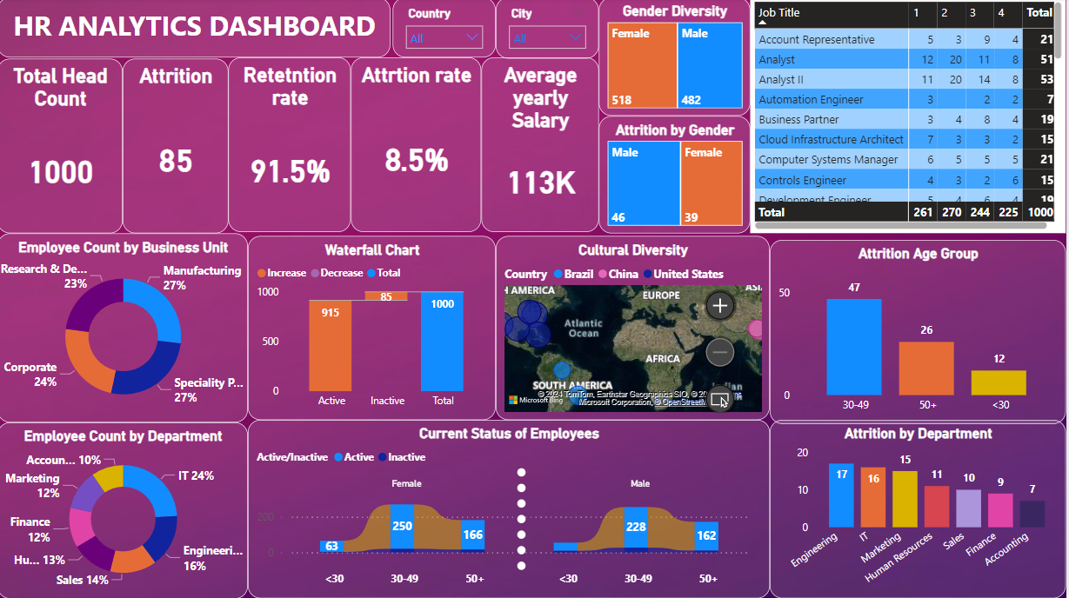

# RESULT AND DISCUSSION

In our HR Analytics Recruitment Analysis using Power BI, we analyzed data from 1,000 employees to uncover key insights into workforce dynamics. Our visualizations provided clear metrics on attrition and retention rates, revealing how these figures are influenced by factors such as age and department. We also examined the average yearly salary across the organization, providing a detailed breakdown that helps assess the effectiveness of current compensation strategies. Additionally, our analysis included attrition rates segmented by age and department, which highlighted specific areas for HR intervention. Cultural diversity and the distribution of employees across various departments were also visualized, offering a broader perspective on the organizational structure and the inclusivity of the workplace environment. These insights collectively assist in strategic decision-making and policy adjustments aimed at enhancing employee satisfaction and organizational efficiency.

# CONCLUSION

In conclusion, our HR Analytics Recruitment Analysis conducted using Power BI on a dataset of 1,000 employees has provided invaluable insights into various facets of workforce management. By visualizing key metrics such as attrition rates, retention rates, salary distributions, attrition by age group and department, cultural diversity, and employee count by department, we have gained a comprehensive understanding of the organization's HR landscape. These insights enable us to make informed decisions and implement targeted strategies to enhance employee satisfaction, improve retention rates, and optimize recruitment processes. Moving forward, the actionable insights derived from this analysis will serve as a roadmap for driving positive changes within the organization, fostering a more productive and inclusive workplace culture.

# REFERENCES

1. Bersin, J. (2015). The datafication of HR. Harvard Business Review, 93(5), 106-114.

2 Davenport, T. H., Harris, J., & Shapiro, J. (2010). Competing on talent analytics. Harvard Business Review, 88(10), 52-58.

3. Boudreau, J. W., & Cascio, W. F. (2017). Human resource analytics: Why it's important and how you can get started. Organizational Dynamics, 46(1), 3-15.

4. Microsoft. (n.d.). Power BI. Retrieved from https://powerbi.microsoft.com/